Exp-2
def hanoi(n, source, auxiliary, target, moves):
if n == 1:
moves.append(f"Move disk 1 from {source} → {target}")
return
hanoi(n-1, source, target, auxiliary, moves)
moves.append(f"Move disk {n} from {source} → {target}")

hanoi(n-1, auxiliary, source, target, moves)

num_disks = 3

moves_list = []
hanoi(num_disks, "A", "B", "C", moves_list)

print(f"\nTotal Moves = {len(moves_list)}\n")
for i, step in enumerate(moves_list, 1):
print(f"Step {i}: {step}")

Output:
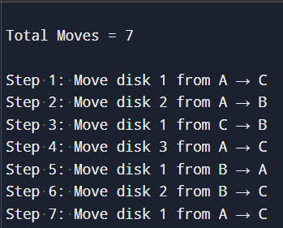

Exp-3
from collections import deque
graph = {
0: [1, 2, 3],
1: [],
2: [4],
3: [],
4: []
}

def bfs(start):
visited = set()
queue = deque([start])

order = [] # To store BFS order

while queue:
node = queue.popleft()

if node not in visited:
visited.add(node)
order.append(node)
for neighbor in graph[node]:
if neighbor not in visited:
queue.append(neighbor)

return order
start_node = 0
result = bfs(start_node)

print("BFS Traversal Order:")
print(result)

Output:
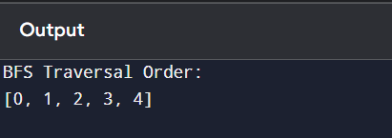
Exp-4

def is_goal(state):
return state == ("banana_location", "banana_location", True)

def get_actions(state):
monkey, box, on_box = state
actions = []
if not on_box:
actions.append(("Move to box", (box, box, False)))
actions.append(("Move to banana", ("banana_location", box, False)))
if monkey == box and not on_box:
actions.append(("Push box to banana", ("banana_location", "banana_location", False)))
if monkey == box and not on_box:
actions.append(("Climb on box", (monkey, box, True)))

return actions

def solve(initial_state):
queue = [initial_state]
visited = set()
parent = {initial_state: None}
action_taken = {initial_state: None}

while queue:
current = queue.pop(0)

if current in visited:
continue

visited.add(current)

# Check if goal reached
if is_goal(current):
# Build action path
path = []
while current is not None:
path.append((current, action_taken[current]))
current = parent[current]
return list(reversed(path))

for action, next_state in get_actions(current):
if next_state not in visited:
queue.append(next_state)
parent[next_state] = current
action_taken[next_state] = action

return None

initial_state = ("door", "window", False)

solution = solve(initial_state)

print("Monkey and Banana Problem Solution:\n")
for step, (state, action) in enumerate(solution):
if action:
print(f"Step {step}: {action}")
print(f" State = Monkey at {state[0]}, Box at {state[1]}, On Box = {state[2]}")

print("\nGoal achieved → Monkey gets the banana! ")
Output:
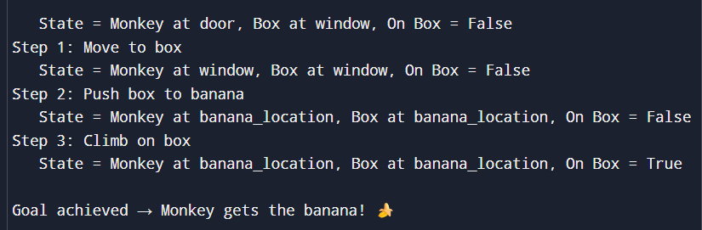

Exp-5
def solve_n_queens(n=8):
solutions = []
def backtrack(row, cols, diag1, diag2, pos):
if row == n:
solutions.append(pos[:])
return
for col in range(n):
if col in cols or (row-col) in diag1 or (row+col) in diag2:
continue
cols.add(col); diag1.add(row-col); diag2.add(row+col)
pos.append(col)
backtrack(row+1, cols, diag1, diag2, pos)
pos.pop()
cols.remove(col); diag1.remove(row-col); diag2.remove(row+col)

backtrack(0, set(), set(), set(), [])
return solutions

def print_board(solution):
n = len(solution)
for r in range(n):
row = ['.'] * n
row[solution[r]] = 'Q'
print(' '.join(row))
print()

if __name__ == "__main__":
sols = solve_n_queens(8)
print("Number of solutions:", len(sols))
for i, sol in enumerate(sols, 1):
print("Solution", i)
print_board(sol)
Output:
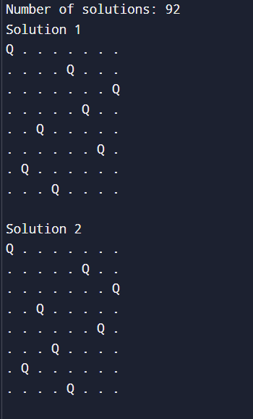

Exp-6
def dfs(graph, start, visited=None):
if visited is None:
visited = set()
print(start, end=" ")
visited.add(start)

for neigh in graph[start]:
if neigh not in visited:
dfs(graph, neigh, visited)

graph = {
'A': ['B', 'C'],
'B': ['D', 'E'],
'C': ['F'],
'D': [],
'E': ['F'],
'F': []
}

print("DFS Traversal:")
dfs(graph, 'A')

Output:
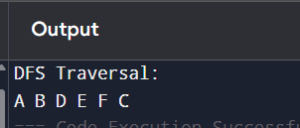
Exp-7
from collections import deque
CAP_A = 4 # 4-gallon jug
CAP_B = 3 # 3-gallon jug

def get_neighbors(state):
"""Return all possible next states from current state."""
x, y = state
neighbors = []
neighbors.append((CAP_A, y)) # fill 4-gallon
neighbors.append((x, CAP_B)) # fill 3-gallon

neighbors.append((0, y)) # empty 4-gallon
neighbors.append((x, 0)) # empty 3-gallon
pour = min(x, CAP_B - y)
neighbors.append((x - pour, y + pour))

pour = min(y, CAP_A - x)
neighbors.append((x + pour, y - pour))

return neighbors

def bfs_water_jug():
start = (0, 0)
goal_x = 2

queue = deque([start])
visited = {start: None}

while queue:
state = queue.popleft()
x, y = state

if x == goal_x:

path = []
while state is not None:
path.append(state)
state = visited[state]
path.reverse()
return path

for nxt in get_neighbors(state):
if nxt not in visited:
visited[nxt] = state
queue.append(nxt)

return None

if __name__ == "__main__":
path = bfs_water_jug()
if path is None:
print("No solution found.")
else:
print("Steps (4-gallon, 3-gallon):")
for step in path:
print(step)
Output:
